Name : Syed Arham (24k-2551)

Class : BSE – 2A

Q1 :-  
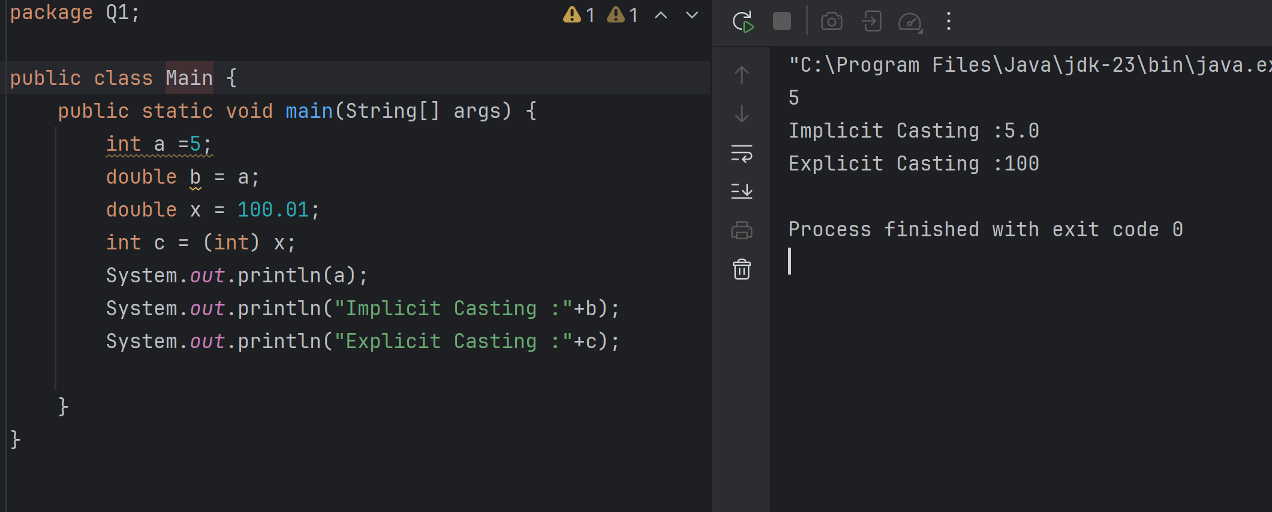

Q2(Same I did both in 1,2 Questions)

Q3:-

Q4:-

Q5:-

Q6:

Q7:  
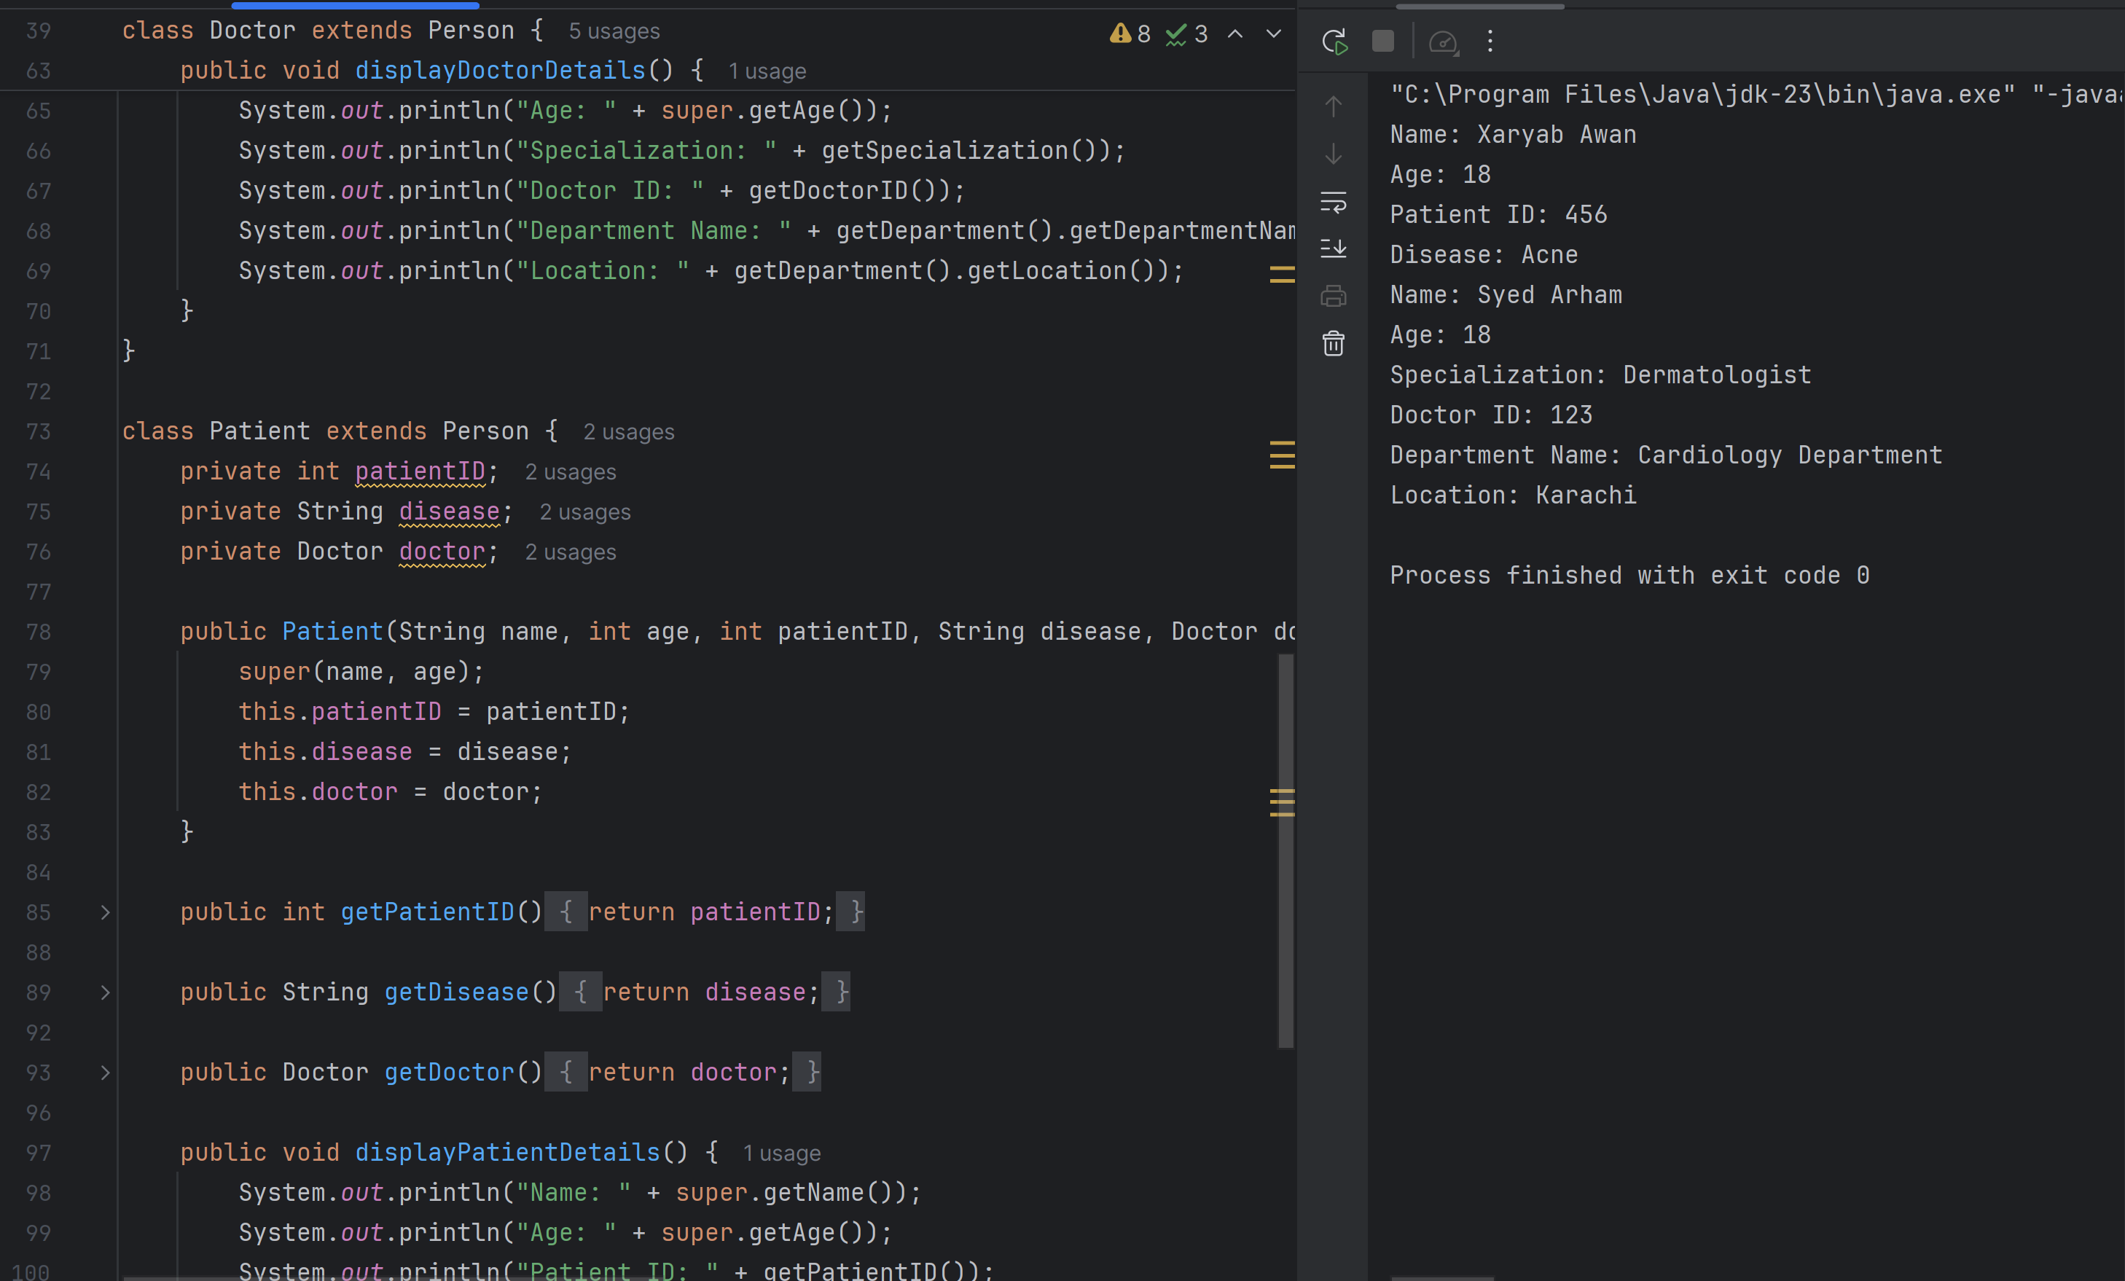

Q8:  
